Lake city Football Club Winner of Futsal 2024

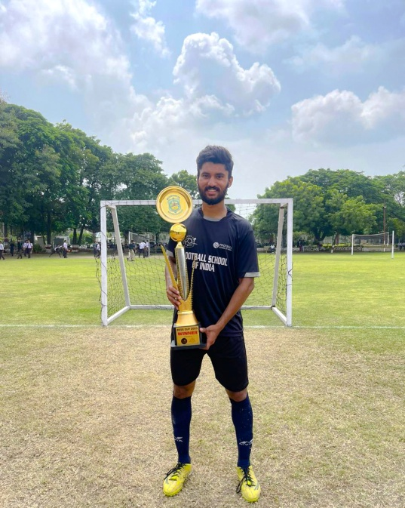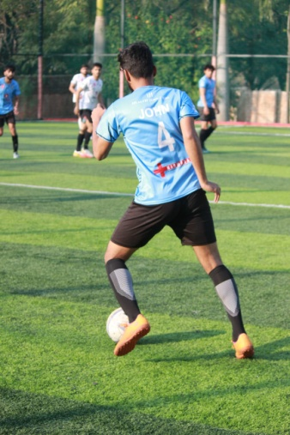 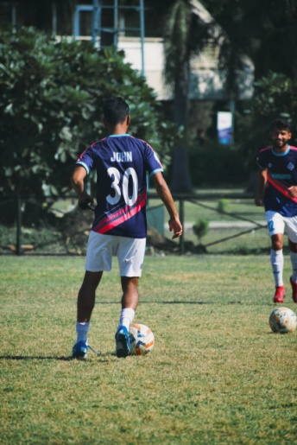 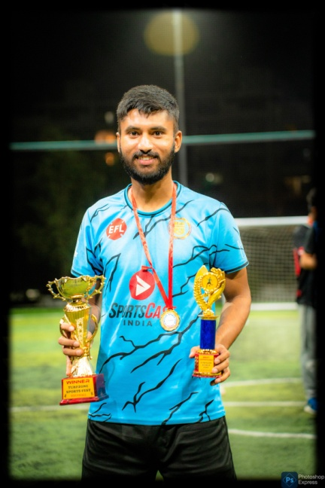

**Winners of BSSS CUP**

**­­**

Winners of BSSS CUP 2023-24 Winners of charity cup 2023

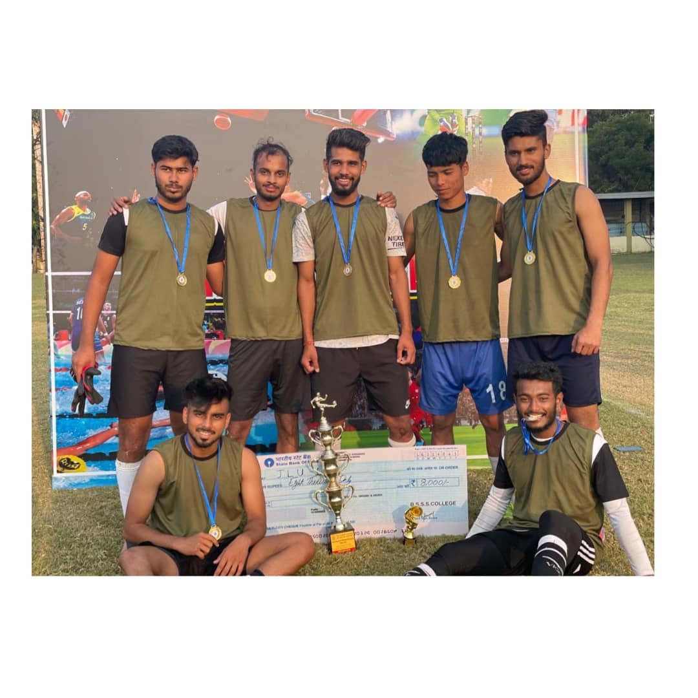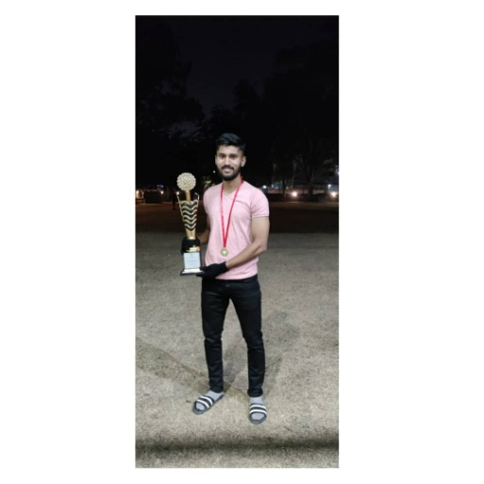

**Trained by RISHISH DUBEY and UEFA PRO LICENCED COACH “JOSE CARLOS RODRIGUEZ HEVIA”UNDER CELTIC SOCCER ACADEMY IN BHOPAL NAMED AS MADHYA BHARAT SPORTS CLUB.**

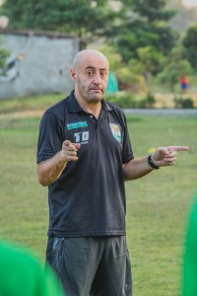

**U-17 Subroto International Football Competition –INTERNATIONAL LEVEL- played for Madhya Pradesh against International teams held at AMBEDKAR STADIUM AND NWC GROUND (AIR FORCE),NEW DELHI.**

* **RUNNER UP- lost in the final in penalties - DFA CUP played in Dewas MP.**
* **U-14 Subroto- cup STATE LEVEL-played for Bhopal against state teams held at Shahdol**
* **BOFA CUP U- 17 WINNERS**
* **District football association U-17 WINNERS Bhopal team**
* **Certificate from Abhishek Yadav former Indian Captain,now a member at all India Football Federation**

**( AIFF),Deepak Mandal-former India player-founder of football school of India**

* **Certificate for playing inter school football matches**
* **Certificate for playing inter house school matches (yellow house) runner ups**
* **Certificate “Praveenya Pramaam Patra” Subroto International Cup-STATE LEVEL –Bhopal team UNDER 14.**
* **Certificate for securing FIRST in the inter house matches in school (SENIOR)**
* **Certificate for securing FIRST in the inter house matches in school (JUNIOR )**
* **RISING STAR AWARD - Most Improved Player by Rishish –Dubey ( COACH) Foot Ball School of India - Bhopal**
* **All videos are available in youtube-Goa super cup-FSI Bhopal**
* **Subroto International Cup-New Delhi ,was broadcasted in Star Sports TV Channel**
* **NAME-JOHN THOMAS POSITION-LEFT WING/LEFTBACK**

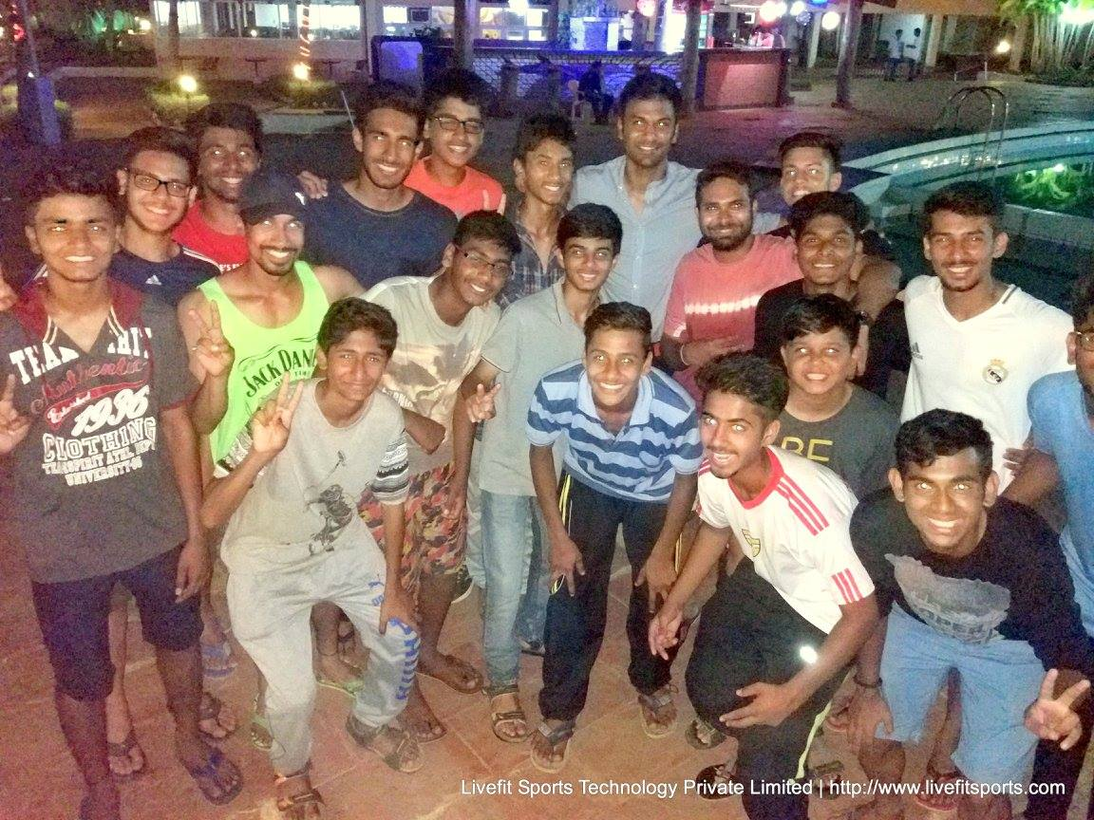

FSI BHOPAL-GOA-PHOTO WITH ABHISHEK YADAV-FORMER INDIA CAPTAIN

MEMBER-TECHNICAL COMMITTEE-ALL INDIA FOOTBALL FEDERATION

SUBROTO STATE WINNERS U-17

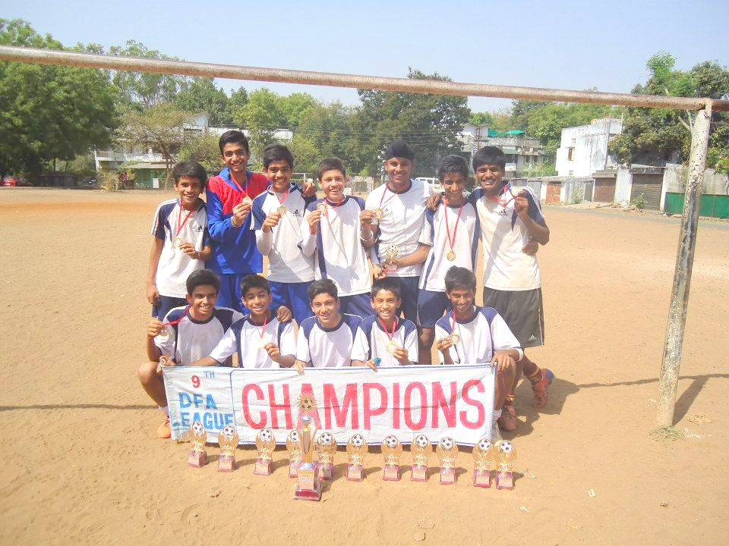 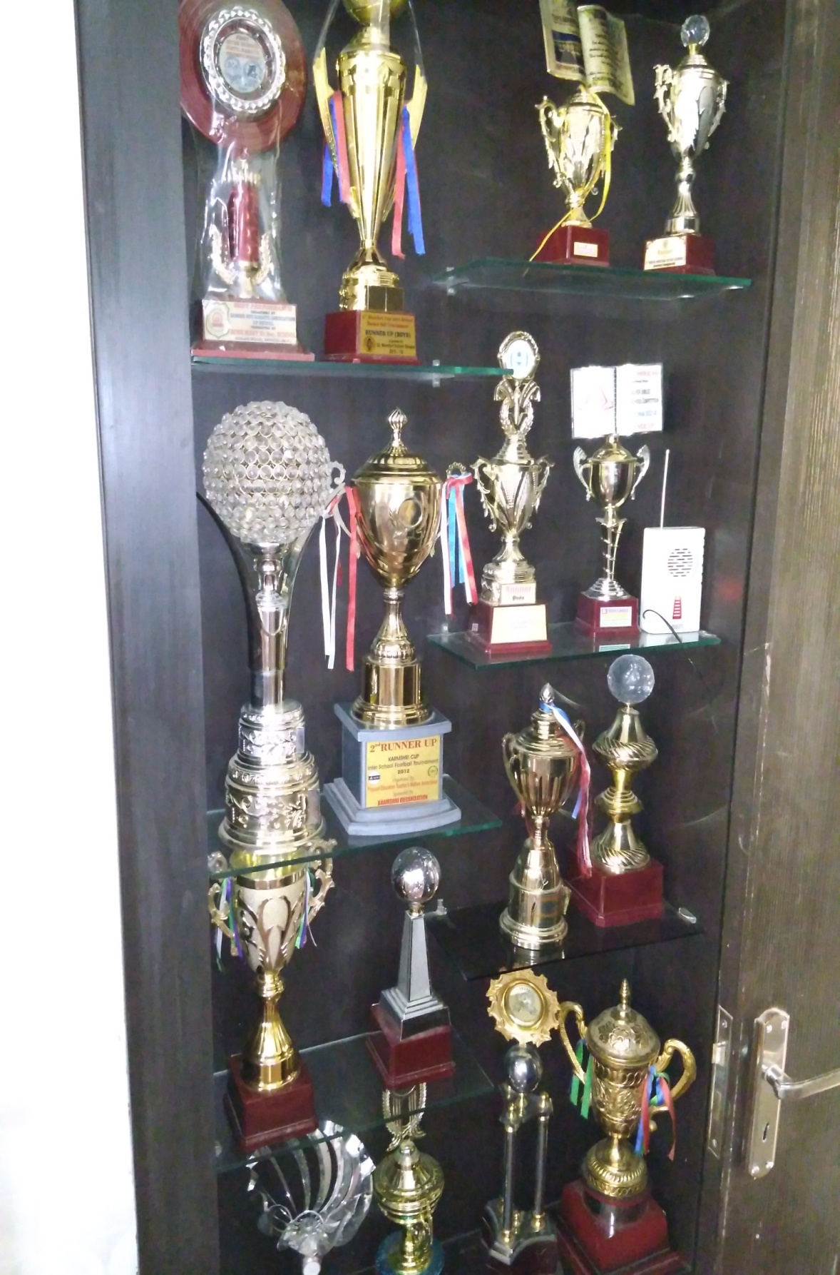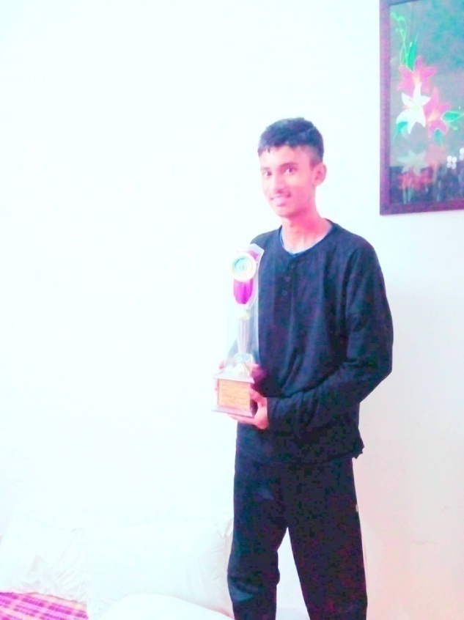

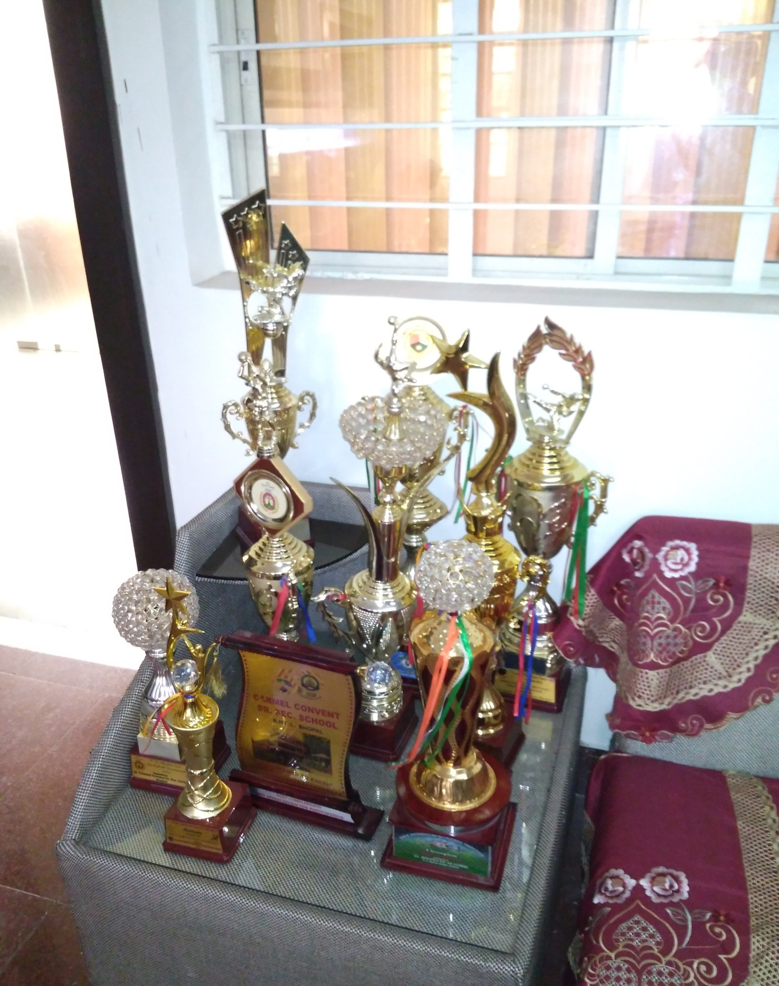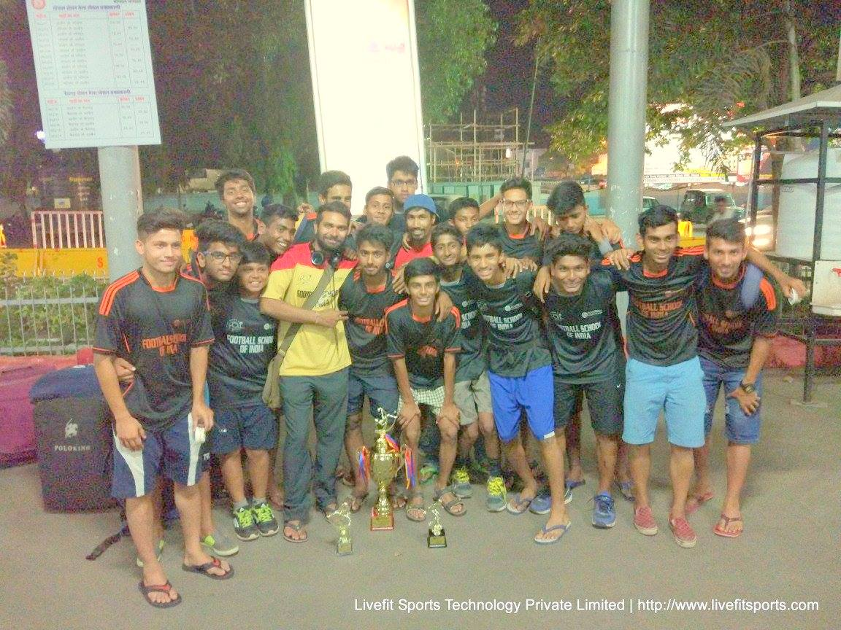 U-17 GOA CUP

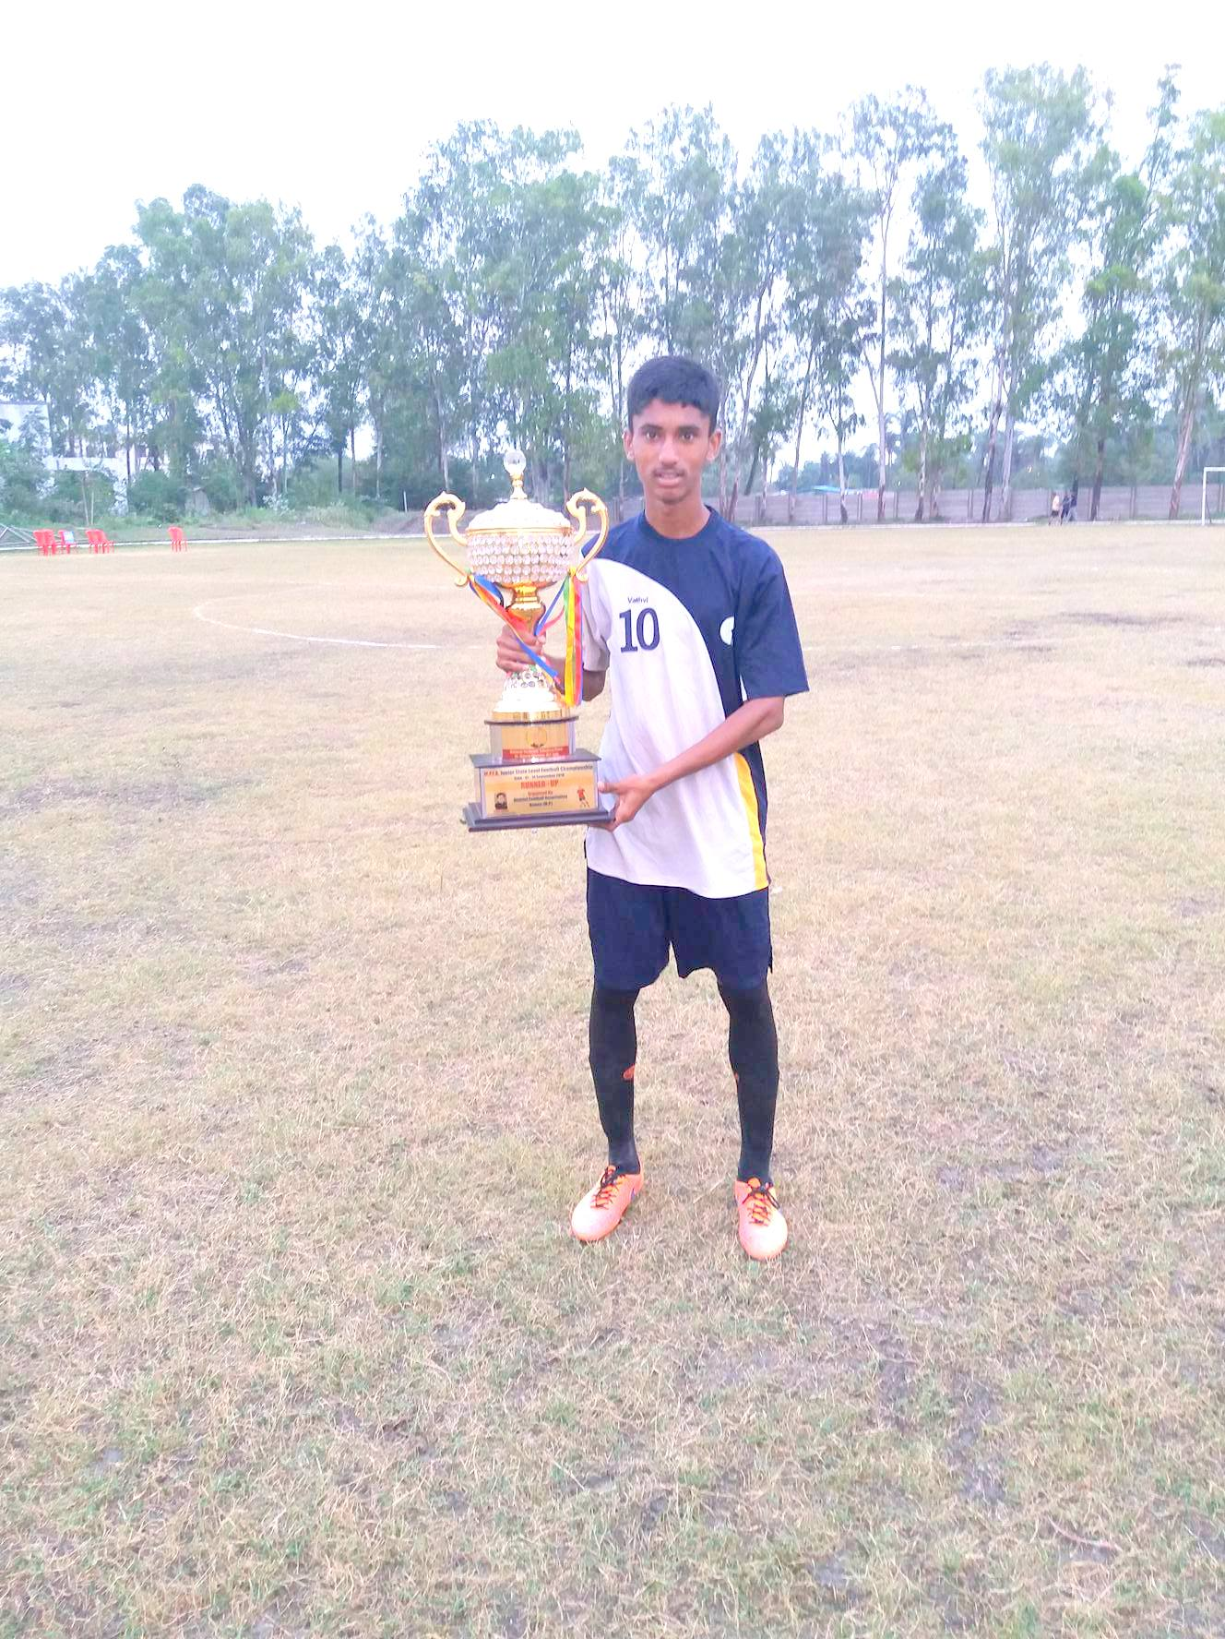 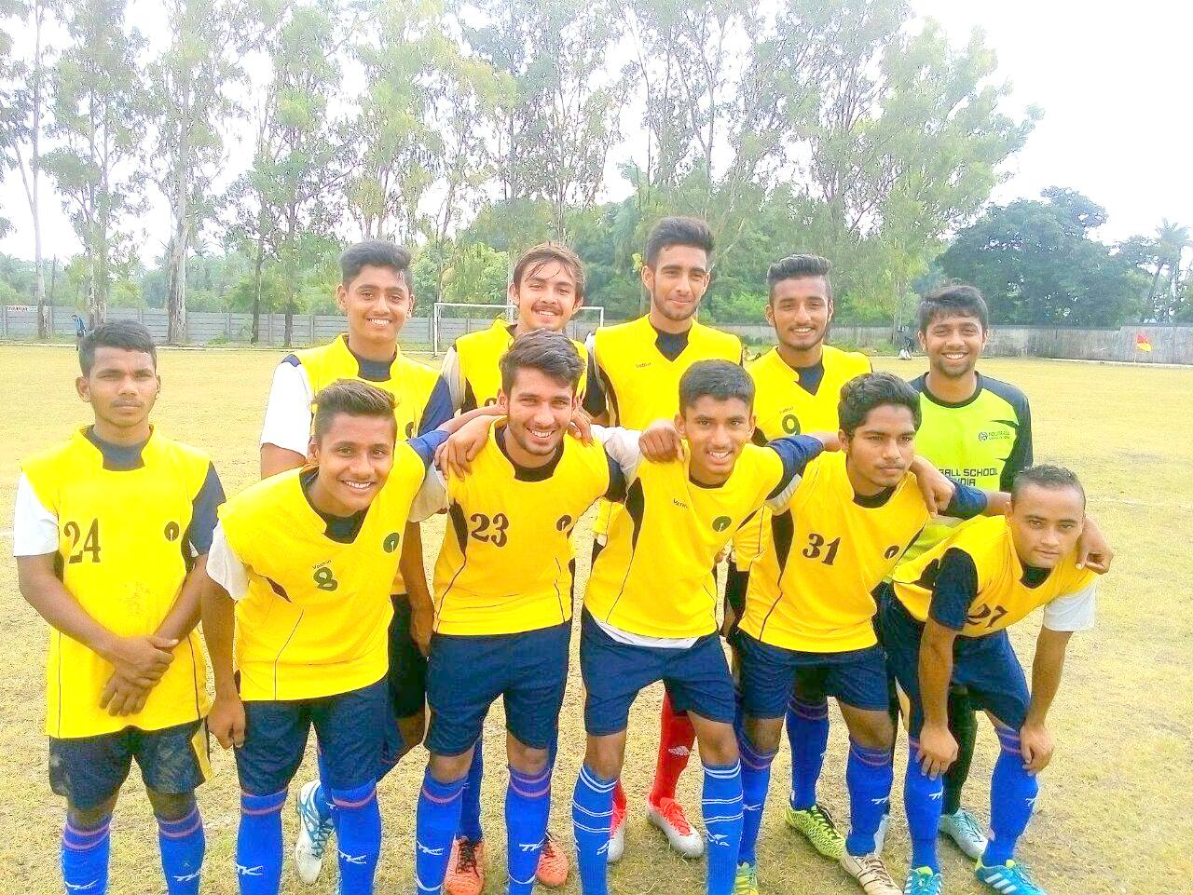**U-17 DFA TEAM**  DISTRICT FOOTBALL ASSOCIATION U-17 WINNERS

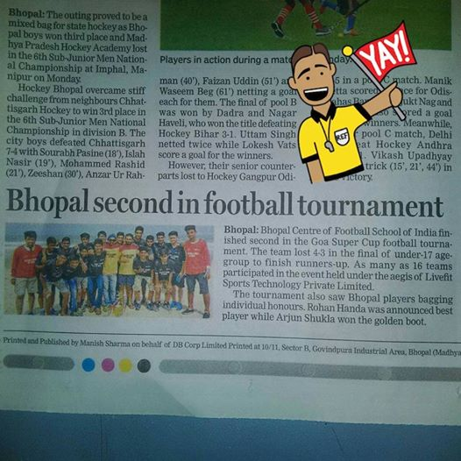

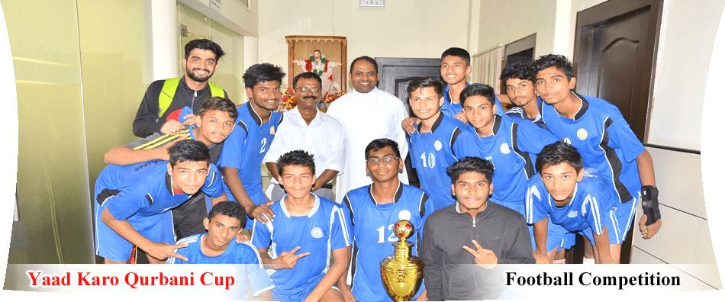

WINNERS U-17 CASH PRIZE OF 36,000 TO BHOPAL TEAM

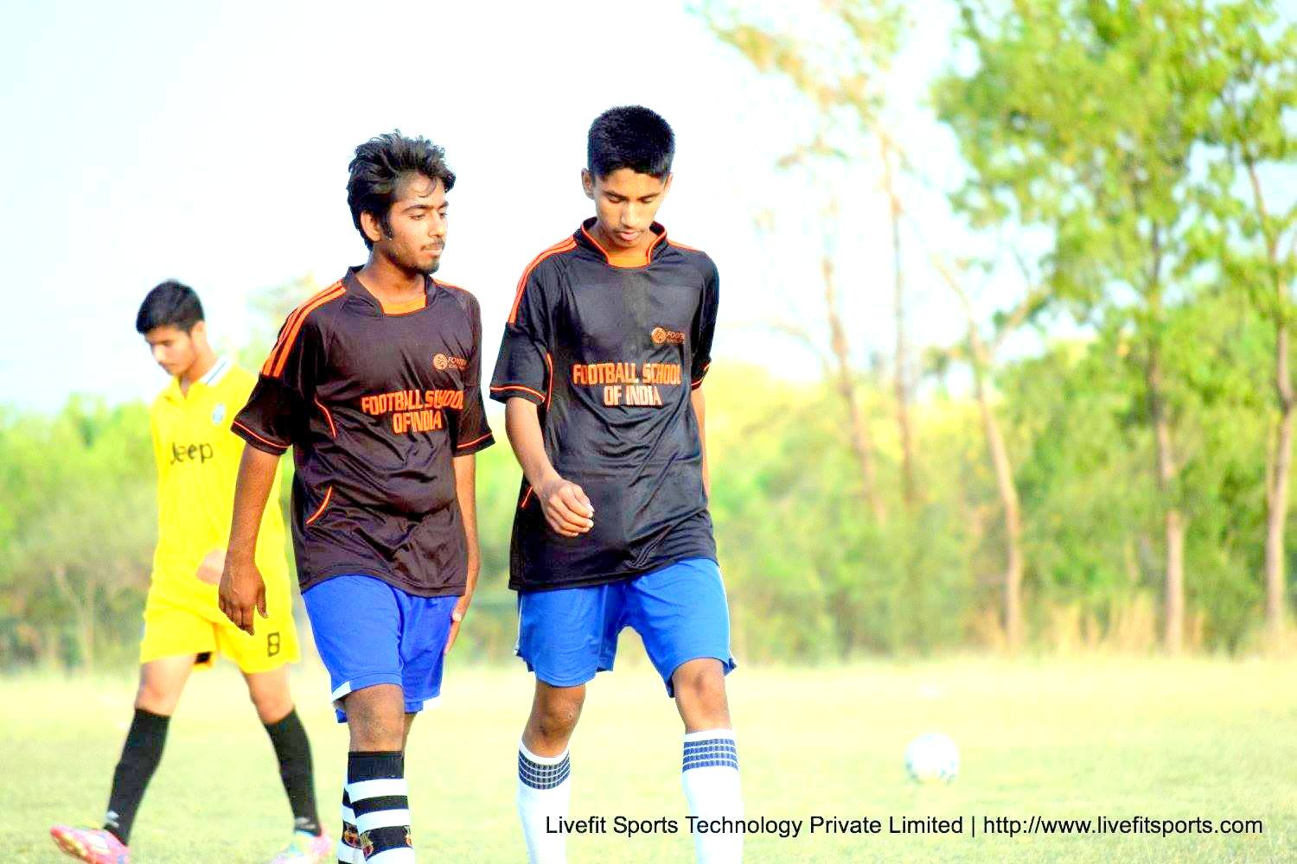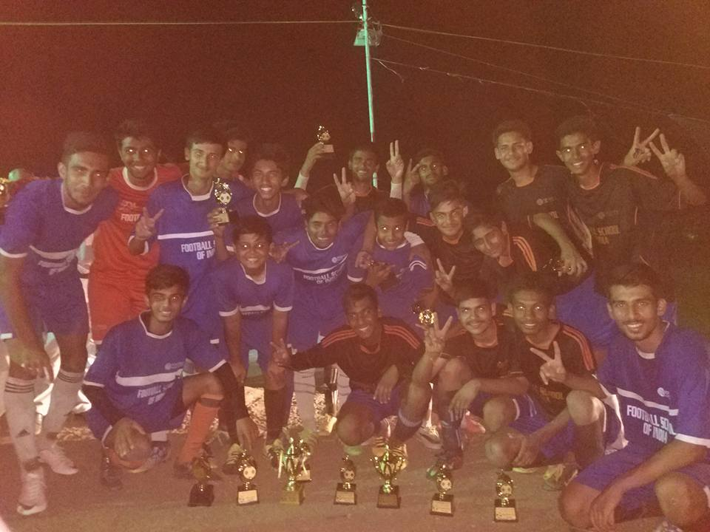

BOFA CUP U-18 WINNERS

BEST PLAYER-ME

FOOTBALL SCHOOL OF INDIA U17 WINNERS

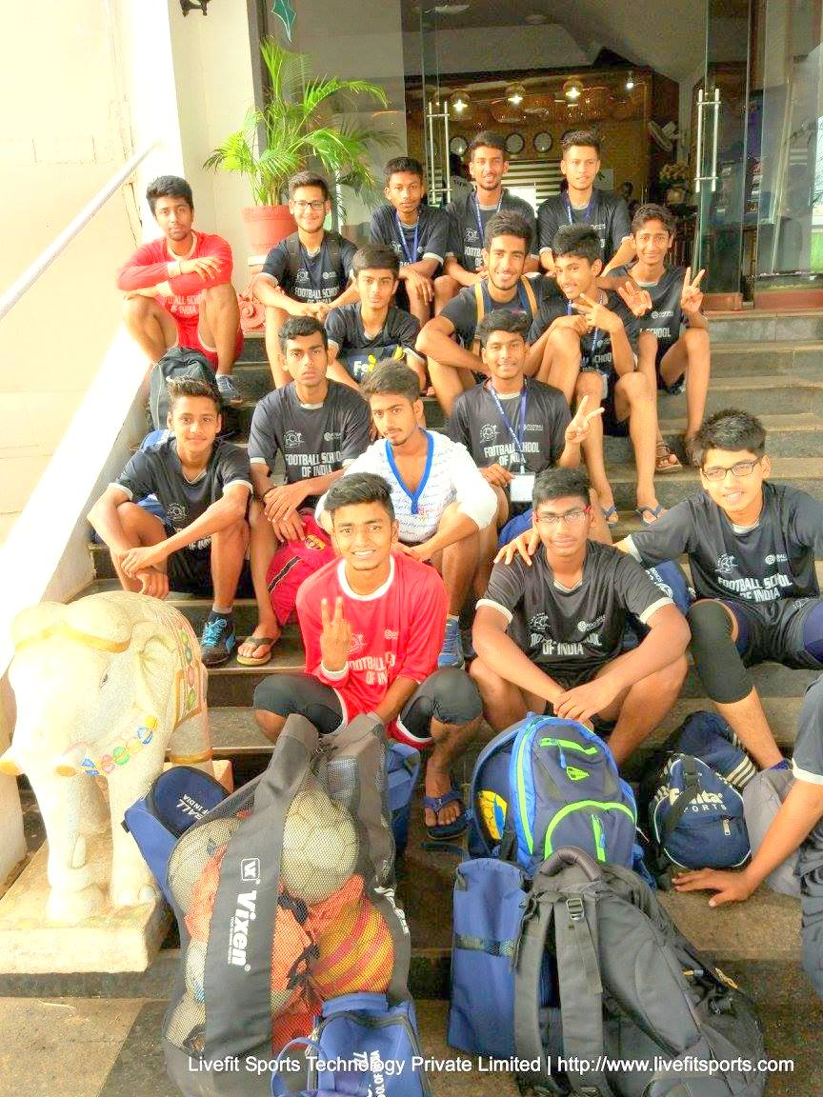

U-17 GOA CUP FOOTBALL SCHOOL OF INDIA-MADHYA PRADESH TEAM

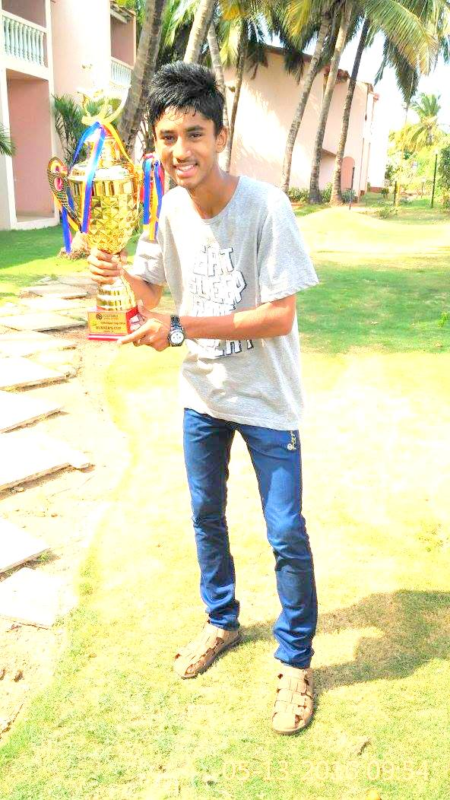

FOOTBALL SCHOOL OF INDIA –GOA CUP RUNNER UP U-17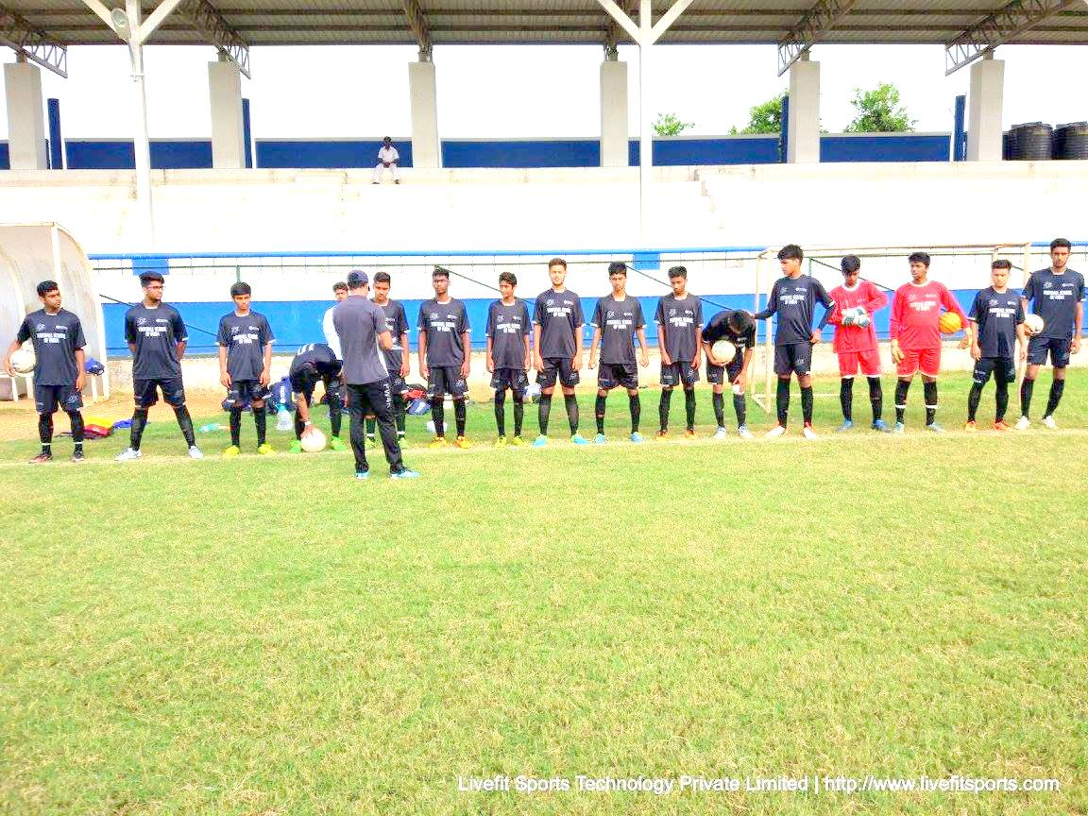

SEMIFINAL GOA CUP LINE UP

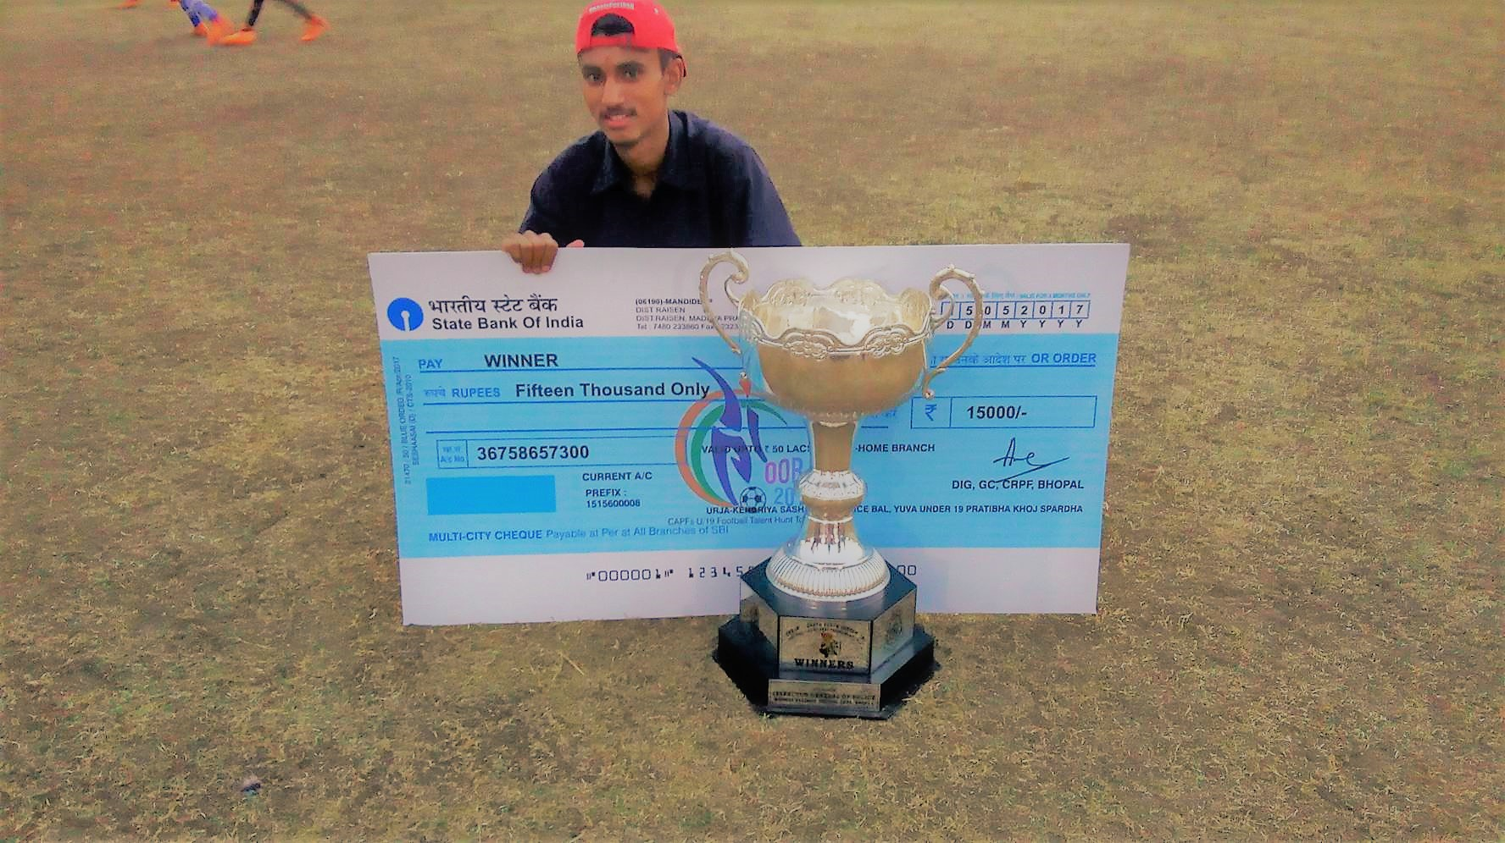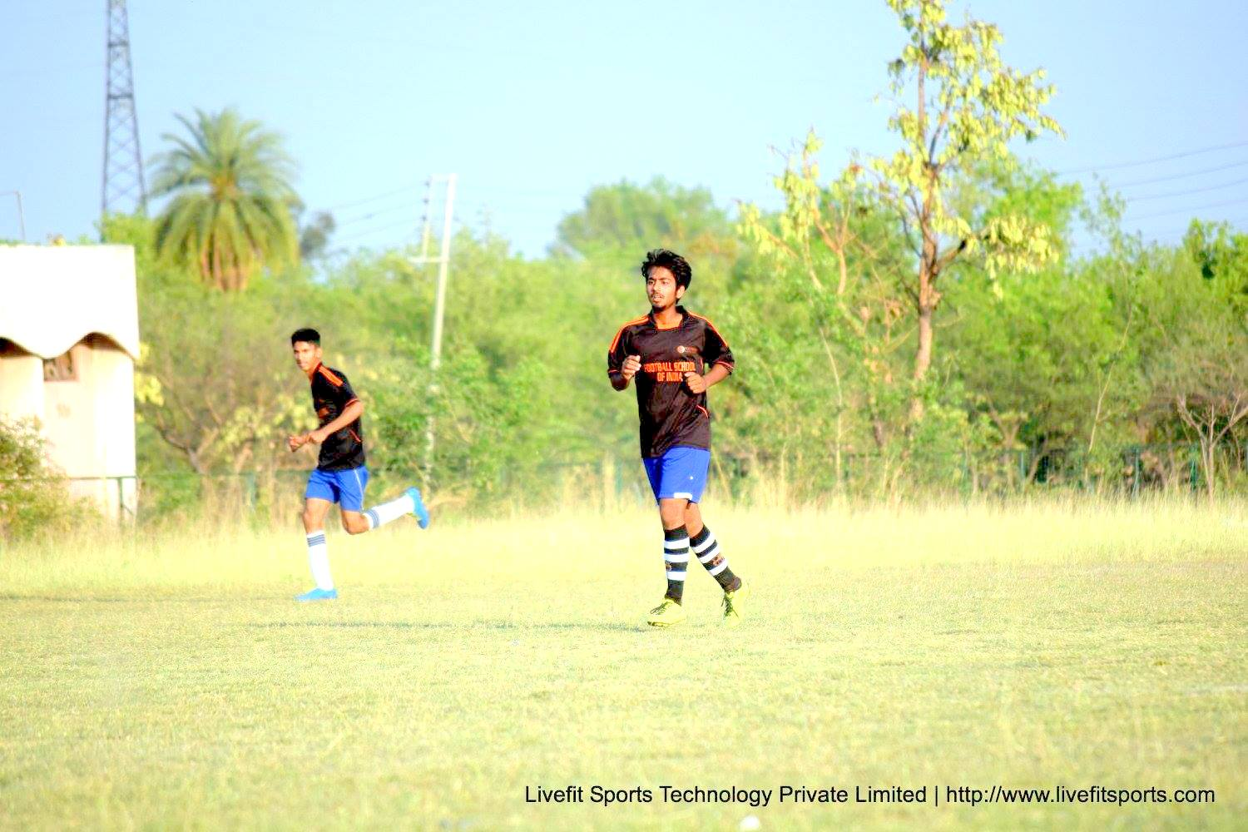

FSI MADHYA PRADESH TEAM VS BARKATULLAH UNIVERSITY FRIENDLY MATCH

OORJA CUP-DISTRICT LEVEL BHOPAL DFA U-19 –WINNERS

CASH PRZE OF 15000

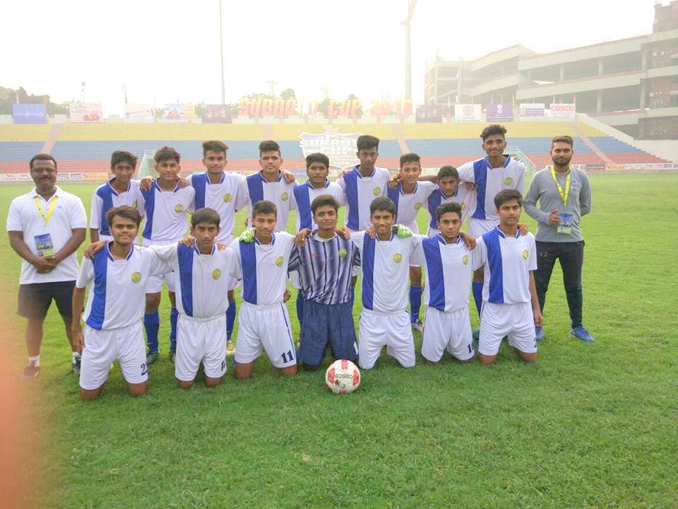

SUBROTO CUP SCHOOL TEAM U-17 INTERNATIONAL LEVEL HELD IN DELHI

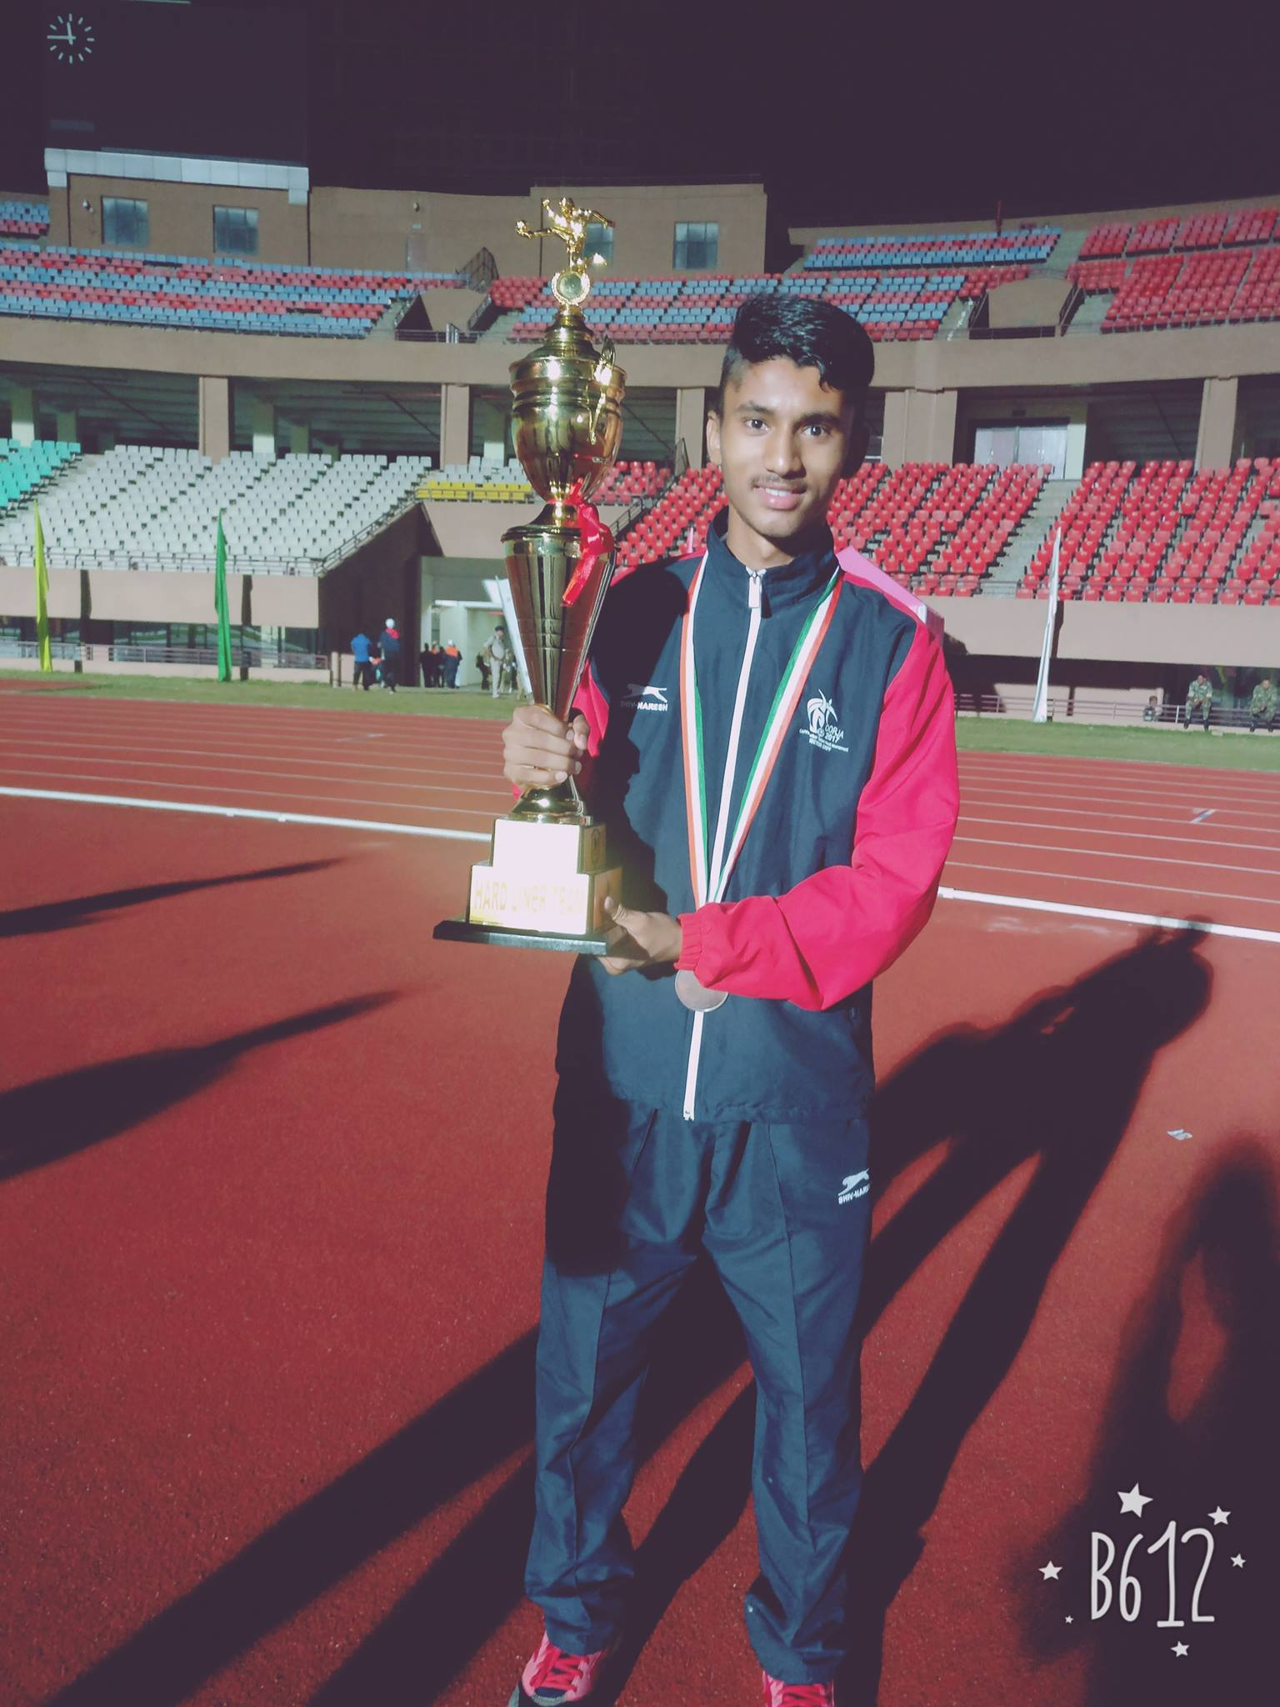

OORJA CUP NATIONAL LEVEL .M.P TEAM 3RD PLACE-CASHPRIZE OF 40000

**Email : akjohnthomas1007@gmail.com**